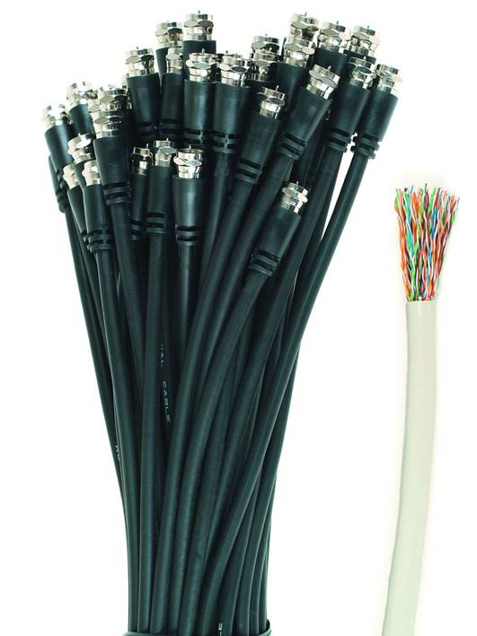

50 COAX CABLE, 50 PAIRS UTP CABLE.

